1. **INTRODUCTION**
   1. *overview*
      * *Description of the project*

Project Description:

* 1. HealthHub Medical Clinic, a healthcare facility, relies on Zoho Books to manage patient billing and invoicing. They can track medical service fees, manage insurance payments, and generate statements for patients. Zoho Books helps them maintain financial transparency and ensures efficient billing processes.
  2. **PURPOSE**

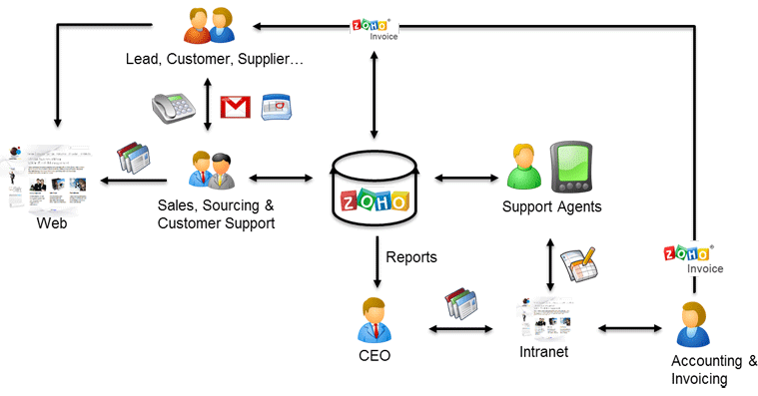

As a Center of Excellence, HealthHub Clinics offers multi-disciplinary resources and smart healthcare solutions, supported by a holistic and compassionate approach, understanding and quality care designed around your health.

1. **Problem definition & design Thinking**
   1. *Empathy map*

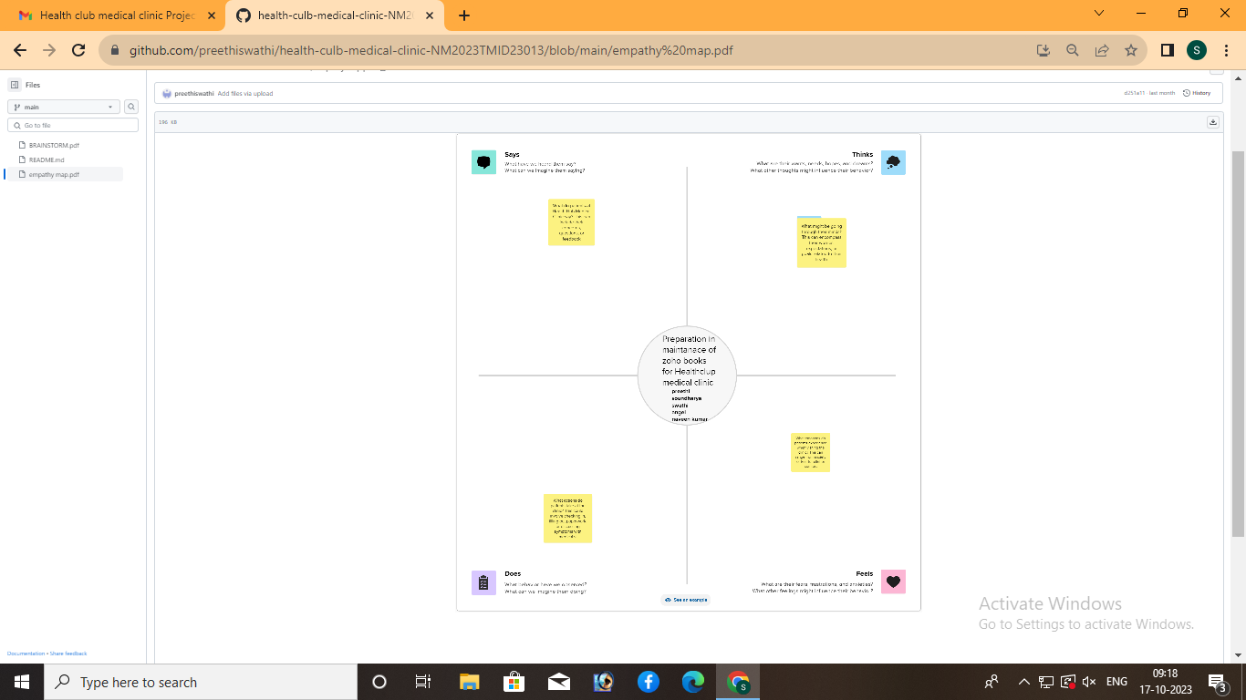

* 1. *Ideation & Brainstorming map*

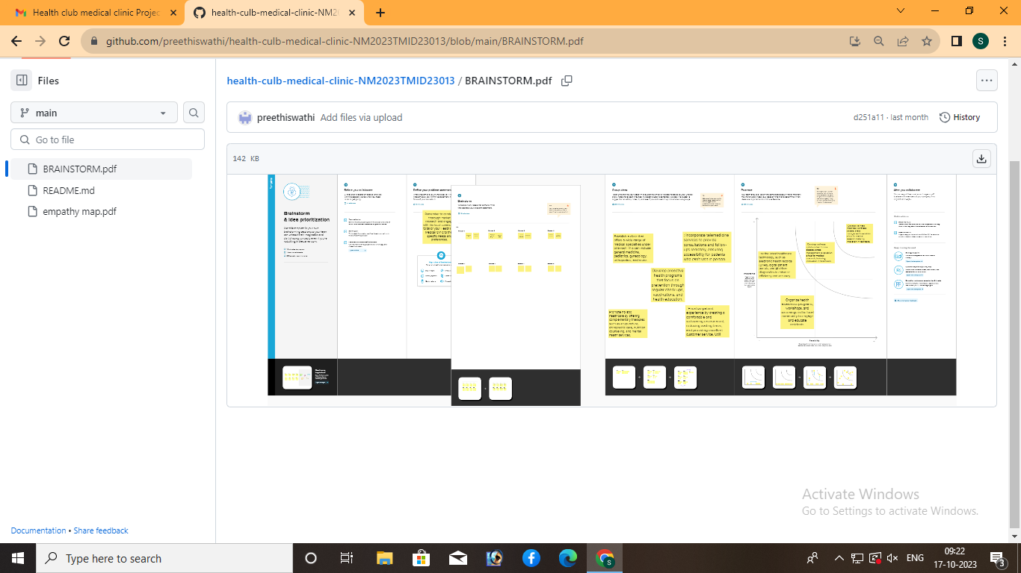

1. **Result Profit&loss**

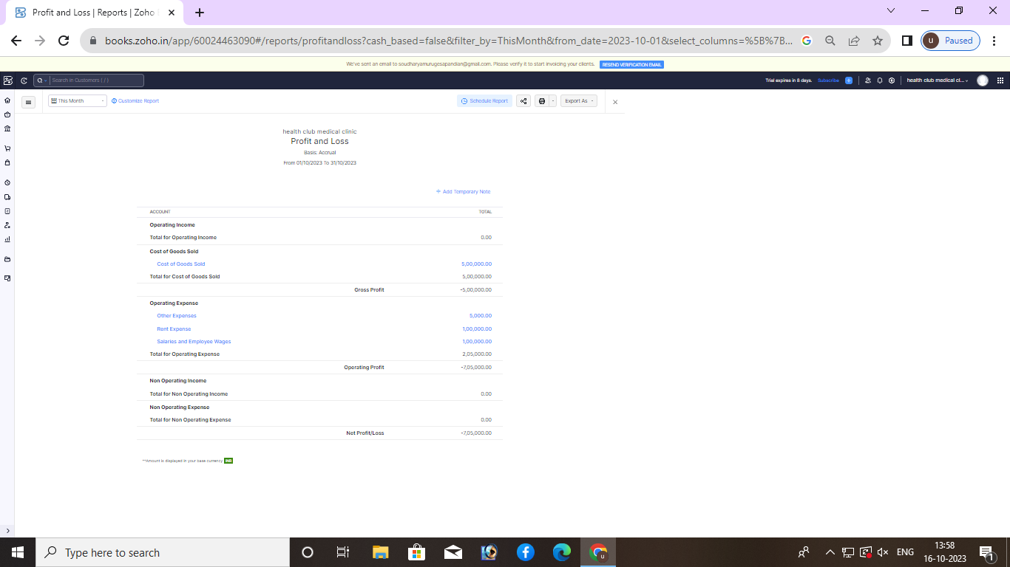

Balance sheet:

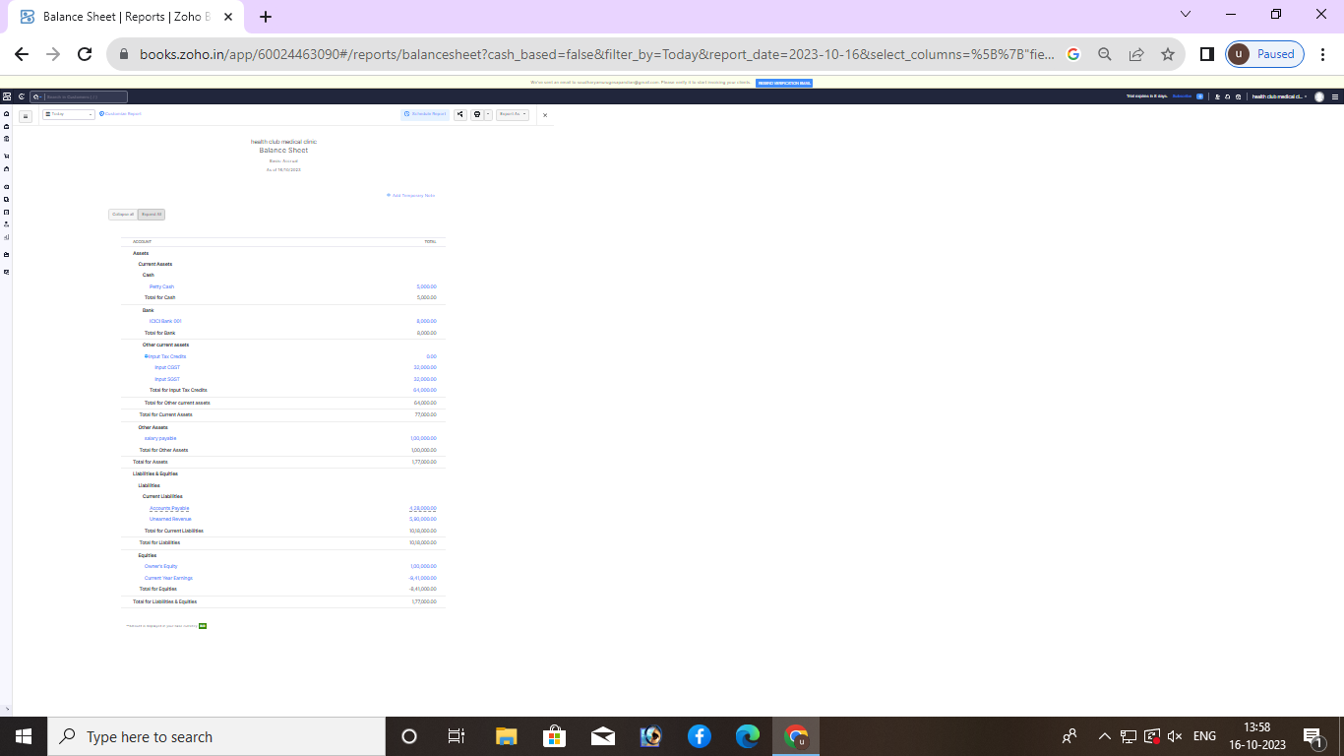

Purchase order:

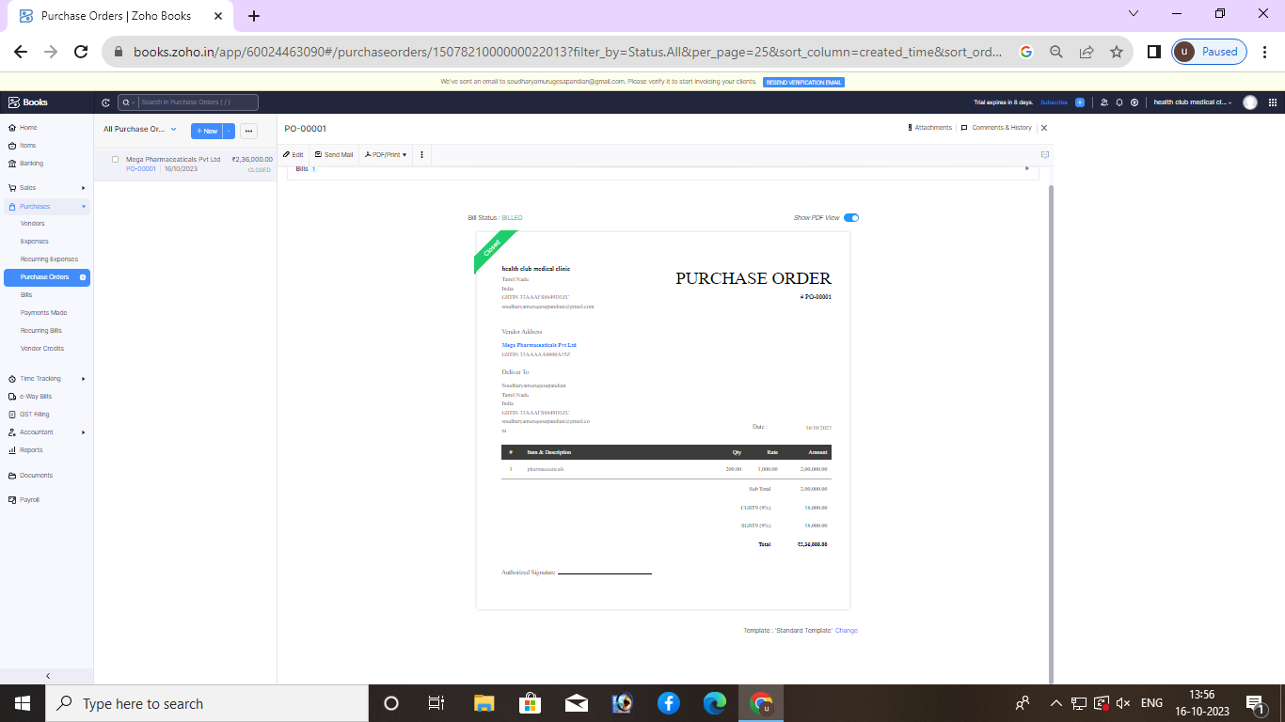

ADVANTAGES OF HEALTHHUB MEDICAL CLINIC:

myHealthHub keeps patients connected to their loved ones and enables virtual care in hospital rooms. By engaging patients, it eliminates many administrative tasks for care providers and reduces the chances of readmission.

DISADVANTAGES OF HEALTHHUB MEDICAL CLINIC:

Doctors are employed by the system. They get the same pay whatever, so they have no motive to increase their costs or buy extras.

1. *APPLICATIONS:*

HEALTHHUB MEDICAL CLINIC.

1. **Conclusion:**

Inadequate healthcare is prevalent globally in all countries, and no country has a perfect healthcare system.

1. **FUTURE SCOPE:**

The Health Hub is a designated European Digital Innovation Hub in Thessaly, lying in the center of Greece, acting as a reference point of Digital Health at regional, national and European level. It is a one-stop-shop that delivers digital transformation services to SMEs and public administrations of the health and pharma sector and supports them in boosting their outreach, precision, innovation capacity, and networking efforts.

1. **APPENDIX:**

[https://drive.google.com/file/d/1UDawIvUXegbXclwXPEH3wipv3OI9IDAS/view?usp=drivesdk](https://drive.google.com/file/d/1UDawIvUXegbXclwXPEH3wipv3OI9IDAS/view?usp=drivesdk%20%20)  DOCTYPE html>

<!—saved from url=(0087)https://

<[!github.com/asmku643mku643c1c31260/NM2023TMID22539/blob/main](https://github.com/asmku643mku643c1c31260/NM2023TMID22539.git)/profit_and_loss.pd f □

<html lang=”en” data-color-mode=”auto” data-light-theme=”light” data-dark-theme=”dark” data-a11y-animated-images=”system” data-a11y-link-underlines=”true”

data-turbo-loaded=””><head><meta http-equiv=”Content-Type” content=”text/html; charset=UTF-8”><style type=”text/css”>.turbo-progress-bar {

Position: fixed; Display: block; Top: 0;

Left: 0; Height: 3px;

Background: #0076ff;

z-index: 2147483647; transition:

width 300ms ease-out, opacity 150ms 150ms ease-in; transform: translate3d(0, 0, 0);

}

</style>

<link crossorigin=”anonymous” media=”all” rel=”stylesheet” href=”./NM2023TMID22539_profit_and_loss.pdf at main · asmku643mku643c1c31260_NM2023TMID22539 · GitHub_files/light-b92e9647318f.css”><link crossorigin=”anonymous” media=”all” rel=”stylesheet” href=”./NM2023TMID22539_profit_and_loss.pdf at main · asmku643mku643c1c31260_NM2023TMID22539 · GitHub_files/dark-5d486a4ede8e.css”><link data-color-theme=”dark_dimmed” crossorigin=”anonymous” media=”all” rel=”stylesheet” data-href=https://github.githubassets.com/assets/dark_dimmed-27c8d635e4e5.css><link data-color-theme=”dark_high_contrast” crossorigin=”anonymous” media=”all”

rel=”stylesheet”

data-href=https://github.githubassets.com/assets/dark_high_contrast-8438e75afd36.css><lin k data-color-theme=”dark_colorblind” crossorigin=”anonymous” media=”all” rel=”stylesheet” data-href=https://github.githubassets.com/assets/dark_colorblind-bf5665b96628.css><link data-color-theme=”light_colorblind” crossorigin=”anonymous” media=”all” rel=”stylesheet” data-href=https://github.githubassets.com/assets/light_colorblind-c414b5ba1dce.css><link data-color-theme=”light_high_contrast” crossorigin=”anonymous” media=”all” rel=”stylesheet”

data-href=https://github.githubassets.com/assets/light_high_contrast-e5868b7374db.css><lin k data-color-theme=”light_tritanopia” crossorigin=”anonymous” media=”all” rel=”stylesheet” data-href=https://github.githubassets.com/assets/light_tritanopia-299ac9c64ec0.css><link data-color-theme=”dark_tritanopia” crossorigin=”anonymous” media=”all” rel=”stylesheet” data-href=h[ttps://github.githubassets.com/assets/dark_tritanopia-3a26e78ad0ff.css>](https://github.githubassets.com/assets/light_high_contrast-e5868b7374db.css)

<link cros[sorigin=”anonymous” media=”all” rel=”stylesheet”](https://github.githubassets.com/assets/dark_tritanopia-3a26e78ad0ff.css) href=”./NM2023TMID22539_profit_and_loss.pdf at main · asmku643mku643c1c31260_NM2023TMID22539 · GitHub_files/primer-primitives-6143c8f97ed1.css”>

<link crossorigin=”anonymous” media=”all” rel=”stylesheet” href=”./NM2023TMID22539_profit_and_loss.pdf at main · asmku643mku643c1c31260_NM2023TMID22539 · GitHub_files/primer-d6dcdf72e61d.css”>

<link crossorigin=”anonymous” media=”all” rel=”stylesheet” href=”./NM2023TMID22539_profit_and_loss.pdf at main · asmku643mku643c1c31260_NM2023TMID22539 · GitHub_files/global-ab1c3e3e5644.css”>

<link crossorigin=”anonymous” media=”all” rel=”stylesheet” href=”./NM2023TMID22539_profit_and_loss.pdf at main · asmku643mku643c1c31260_NM2023TMID22539 · GitHub_files/github-757ef6ea9a38.css”>

<link crossorigin=”anonymous” media=”all” rel=”stylesheet” href=”./NM2023TMID22539_profit_and_loss.pdf at main · asmku643mku643c1c31260_NM2023TMID22539 · GitHub_files/code-71ecd5638fbf.css”>

<script type=”application/json”

id=”client-env”>{“locale”:”en”,”featureFlags”:[“failbot_handle_non_errors”,”geojson_azure_m aps”,”image_metric_tracking”,”turbo_experiment_risky”,”sample_network_conn_type”]}</scri pt>

<script crossorigin=”anonymous” defer=”defer” type=”application/javascript” src=”./NM2023TMID22539_profit_and_loss.pdf at main · asmku643mku643c1c31260_NM2023TMID22539 ·

GitHub_files/wp-runtime-86f14561f3b0.js.download”></script>

<script crossorigin=”anonymous” defer=”defer” type=”application/javascript” src=”./NM2023TMID22539_profit_and_loss.pdf at main · asmku643mku643c1c31260_NM2023TMID22539 ·

GitHub_files/vendors-node_modules_dompurify_dist_purify_js-64d590970fa6.js.download”>

</script>

<script crossorigin=”anonymous” defer=”defer” type=”application/javascript” src=”./NM2023TMID22539_profit_and_loss.pdf at main · asmku643mku643c1c31260_NM2023TMID22539 ·

GitHub_files/vendors-node_modules_stacktrace-parser_dist_stack-trace-parser_esm_js-node_ modules_github_bro-a4c183-18bf85b8e9f4.js.download”></script>

<script crossorigin=”anonymous” defer=”defer” type=”application/javascript” src=”./NM2023TMID22539_profit_and_loss.pdf at main · asmku643mku643c1c31260_NM2023TMID22539 ·

GitHub_files/ui_packages_soft-nav_soft-nav_ts-56133143b228.js.download”></script>

<script crossorigin=”anonymous” defer=”defer” type=”application/javascript” src=”./NM2023TMID22539_profit_and_loss.pdf at main · asmku643mku643c1c31260_NM2023TMID22539 ·

GitHub_files/environment-fc6543d75794.js.download”></script>

<script crossorigin=”anonymous” defer=”defer” type=”application/javascript” src=”./NM2023TMID22539_profit_and_loss.pdf at main · asmku643mku643c1c31260_NM2023TMID22539 ·

GitHub_files/vendors-node_modules_github_selector-observer_dist_index_esm_js-2646a2c53 3e3.js.download”></script>

<script crossorigin=”anonymous” defer=”defer” type=”application/javascript” src=”./NM2023TMID22539_profit_and_loss.pdf at main · asmku643mku643c1c31260_NM2023TMID22539 ·

GitHub_files/vendors-node_modules_primer_behaviors_dist_esm_focus-zone_js-d55308df50 23.js.download”></script>

<script crossorigin=”anonymous” defer=”defer” type=”application/javascript” src=”./NM2023TMID22539_profit_and_loss.pdf at main · asmku643mku643c1c31260_NM2023TMID22539 ·

GitHub_files/vendors-node_modules_github_relative-time-element_dist_index_js-99e288659 d4f.js.download”></script>

<script crossorigin=”anonymous” defer=”defer” type=”application/javascript” src=”./NM2023TMID22539_profit_and_loss.pdf at main · asmku643mku643c1c31260_NM2023TMID22539 ·

GitHub_files/vendors-node_modules_fzy_js_index_js-node_modules_github_combobox-nav_ dist_index_js-node_modu-344bff-91b70bb50d68.js.download”></script>

<script crossorigin=”anonymous” defer=”defer” type=”application/javascript” src=”./NM2023TMID22539_profit_and_loss.pdf at main · asmku643mku643c1c31260_NM2023TMID22539 ·

GitHub_files/vendors-node_modules_delegated-events_dist_index_js-node_modules_github_ auto-complete-element-81d69b-f766607dc0c8.js.download”></script>

<script crossorigin=”anonymous” defer=”defer” type=”application/javascript” src=”./NM2023TMID22539_profit_and_loss.pdf at main · asmku643mku643c1c31260_NM2023TMID22539 ·

GitHub_files/vendors-node_modules_github_filter-input-element_dist_index_js-node_module s_github_remote-inp-2e8678-d593bf262480.js.download”></script>

<script crossorigin=”anonymous” defer=”defer” type=”application/javascript” src=”./NM2023TMID22539_profit_and_loss.pdf at main · asmku643mku643c1c31260_NM2023TMID22539 ·

GitHub_files/vendors-node_modules_github_file-attachment-element_dist_index_js-node_m odules_primer_view-co-70ad06-9f8bb7e4a8fa.js.download”></script>

<script crossorigin=”anonymous” defer=”defer” type=”application/javascript” src=”./NM2023TMID22539_profit_and_loss.pdf at main · asmku643mku643c1c31260_NM2023TMID22539 ·

GitHub_files/github-elements-30961cfd137b.js.download”></script>

<script crossorigin=”anonymous” defer=”defer” type=”application/javascript” src=”./NM2023TMID22539_profit_and_loss.pdf at main · asmku643mku643c1c31260_NM2023TMID22539 ·

GitHub_files/element-registry-e5f51987a7c5.js.download”></script>

<script crossorigin=”anonymous” defer=”defer” type=”application/javascript” src=”./NM2023TMID22539_profit_and_loss.pdf at main · asmku643mku643c1c31260_NM2023TMID22539 ·

GitHub_files/vendors-node_modules_lit-html_lit-html_js-4ccebb6ebf7d.js.download”></script

>

<script crossorigin=”anonymous” defer=”defer” type=”application/javascript” src=”./NM2023TMID22539_profit_and_loss.pdf at main · asmku643mku643c1c31260_NM2023TMID22539 ·

GitHub_files/vendors-node_modules_github_mini-throttle_dist_index_js-node_modules_gith ub_alive-client_dist-bf5aa2-504c8d53fb8e.js.download”></script>

<script crossorigin=”anonymous” defer=”defer” type=”application/javascript” src=”./NM2023TMID22539_profit_and_loss.pdf at main · asmku643mku643c1c31260_NM2023TMID22539 ·

GitHub_files/vendors-node_modules_morphdom_dist_morphdom-esm_js-b1fdd7158cf0.js.do wnload”></script>

<script crossorigin=”anonymous” defer=”defer” type=”application/javascript” src=”./NM2023TMID22539_profit_and_loss.pdf at main · asmku643mku643c1c31260_NM2023TMID22539 ·

GitHub_files/vendors-node_modules_github_turbo_dist_turbo_es2017-esm_js-9a3541181451

.js.download”></script>

<script crossorigin=”anonymous” defer=”defer” type=”application/javascript” src=”./NM2023TMID22539_profit_and_loss.pdf at main · asmku643mku643c1c31260_NM2023TMID22539 ·

GitHub_files/vendors-node_modules_github_remote-form_dist_index_js-node_modules_scrol l-anchoring_dist_scro-52dc4b-e1e33bfc0b7e.js.download”></script>

<script crossorigin=”anonymous” defer=”defer” type=”application/javascript” src=”./NM2023TMID22539_profit_and_loss.pdf at main · asmku643mku643c1c31260_NM2023TMID22539 ·

GitHub_files/vendors-node_modules_color-convert_index_js-35b3ae68c408.js.download”></s cript>

<script crossorigin=”anonymous” defer=”defer” type=”application/javascript” src=”./NM2023TMID22539_profit_and_loss.pdf at main · asmku643mku643c1c31260_NM2023TMID22539 ·

GitHub_files/vendors-node_modules_primer_behaviors_dist_esm_dimensions_js-node_modu les_github_jtml_lib_index_js-a18147cea3a6.js.download”></script>

<script crossorigin=”anonymous” defer=”defer” type=”application/javascript” src=”./NM2023TMID22539_profit_and_loss.pdf at main ·

asmku643mku643c1c31260_NM2023TMID22539 ·

GitHub_files/vendors-node_modules_github_paste-markdown_dist_index_esm_js-node_mod ules_github_quote-select-581a1f-4a3074d34892.js.download”></script>

<script crossorigin=”anonymous” defer=”defer” type=”application/javascript” src=”./NM2023TMID22539_profit_and_loss.pdf at main · asmku643mku643c1c31260_NM2023TMID22539 · GitHub_files/app_assets_modules_github_details-dialog_ts-app_assets_modules_github_fetc h_ts-add1ab03ecb3.js.download”></script>

<script crossorigin=”anonymous” defer=”defer” type=”application/javascript” src=”./NM2023TMID22539_profit_and_loss.pdf at main · asmku643mku643c1c31260_NM2023TMID22539 · GitHub_files/app_assets_modules_github_updatable-content_ts-ui_packages_hydro-analytics

_hydro-analytics_ts-0a5a30c9b976.js.download”></script>

<script crossorigin=”anonymous” defer=”defer” type=”application/javascript” src=”./NM2023TMID22539_profit_and_loss.pdf at main · asmku643mku643c1c31260_NM2023TMID22539 · GitHub_files/app_assets_modules_github_onfocus_ts-app_assets_modules_github_sticky-scr oll-into-view_ts-c56a5dfc8975.js.download”></script>

<script crossorigin=”anonymous” defer=”defer” type=”application/javascript” src=”./NM2023TMID22539_profit_and_loss.pdf at main · asmku643mku643c1c31260_NM2023TMID22539 · GitHub_files/app_assets_modules_github_behaviors_task-list_ts-app_assets_modules_github

_sso_ts-ui_packages-7d50ad-9491f2be61ee.js.download”></script>

<script crossorigin=”anonymous” defer=”defer” type=”application/javascript” src=”./NM2023TMID22539_profit_and_loss.pdf at main · asmku643mku643c1c31260_NM2023TMID22539 · GitHub_files/app_assets_modules_github_behaviors_ajax-error_ts-app_assets_modules_gith ub_behaviors_include-2e2258-d77f85c54572.js.download”></script>

<script crossorigin=”anonymous” defer=”defer” type=”application/javascript” src=”./NM2023TMID22539_profit_and_loss.pdf at main · asmku643mku643c1c31260_NM2023TMID22539 · GitHub_files/app_assets_modules_github_behaviors_commenting_edit_ts-app_assets_modul es_github_behaviors_ht-83c235-f22ac6b94445.js.download”></script>

<script crossorigin=”anonymous” defer=”defer” type=”application/javascript” src=”./NM2023TMID22539_profit_and_loss.pdf at main · asmku643mku643c1c31260_NM2023TMID22539 ·

GitHub_files/behaviors-8e3546d05c82.js.download”></script>

<script crossorigin=”anonymous” defer=”defer” type=”application/javascript” src=”./NM2023TMID22539_profit_and_loss.pdf at main · asmku643mku643c1c31260_NM2023TMID22539 ·

GitHub_files/vendors-node_modules_delegated-events_dist_index_js-node_modules_github_ catalyst_lib_index_js-623425af41e1.js.download”></script>

<script crossorigin=”anonymous” defer=”defer” type=”application/javascript” src=”./NM2023TMID22539_profit_and_loss.pdf at main · asmku643mku643c1c31260_NM2023TMID22539 ·

GitHub_files/notifications-global-0104a8043aa4.js.download”></script>

<script crossorigin=”anonymous” defer=”defer” type=”application/javascript” src=”./NM2023TMID22539_profit_and_loss.pdf at main · asmku643mku643c1c31260_NM2023TMID22539 ·

GitHub_files/vendors-node_modules_optimizely_optimizely-sdk_dist_optimizely_browser_es

_min_js-node_modules-089adc-8794271c9a65.js.download”></script>

<script crossorigin=”anonymous” defer=”defer” type=”application/javascript” src=”./NM2023TMID22539_profit_and_loss.pdf at main · asmku643mku643c1c31260_NM2023TMID22539 ·

GitHub_files/optimizely-b8ae60018b11.js.download”></script>

<script crossorigin=”anonymous” defer=”defer” type=”application/javascript” src=”./NM2023TMID22539_profit_and_loss.pdf at main · asmku643mku643c1c31260_NM2023TMID22539 ·

GitHub_files/vendors-node_modules_virtualized-list_es_index_js-node_modules_github_tem plate-parts_lib_index_js-677582870bfd.js.download”></script>

<script crossorigin=”anonymous” defer=”defer” type=”application/javascript” src=”./NM2023TMID22539_profit_and_loss.pdf at main · asmku643mku643c1c31260_NM2023TMID22539 ·

GitHub_files/vendors-node_modules_github_remote-form_dist_index_js-node_modules_dele gated-events_dist_inde-c537341-13ba07af3b2c.js.download”></script>

<script crossorigin=”anonymous” defer=”defer” type=”application/javascript” src=”./NM2023TMID22539_profit_and_loss.pdf at main · asmku643mku643c1c31260_NM2023TMID22539 · GitHub_files/app_assets_modules_github_ref-selector_ts-cad36de2ca60.js.download”></scrip t>

<script crossorigin=”anonymous” defer=”defer” type=”application/javascript” src=”./NM2023TMID22539_profit_and_loss.pdf at main ·

asmku643mku643c1c31260_NM2023TMID22539 · GitHub_files/codespaces-d5d24842ceda.js.download”></script>

<script crossorigin=”anonymous” defer=”defer” type=”application/javascript” src=”./NM2023TMID22539_profit_and_loss.pdf at main · asmku643mku643c1c31260_NM2023TMID22539 ·

GitHub_files/vendors-node_modules_github_filter-input-element_dist_index_js-node_module s_github_mini-throt-08ab15-d50c69097a3e.js.download”></script>

<script crossorigin=”anonymous” defer=”defer” type=”application/javascript” src=”./NM2023TMID22539_profit_and_loss.pdf at main · asmku643mku643c1c31260_NM2023TMID22539 ·

GitHub_files/vendors-node_modules_github_file-attachment-element_dist_index_js-node_m odules_github_mini-th-55cf52-b2acd5425c7c.js.download”></script>

<script crossorigin=”anonymous” defer=”defer” type=”application/javascript” src=”./NM2023TMID22539_profit_and_loss.pdf at main · asmku643mku643c1c31260_NM2023TMID22539 ·

GitHub_files/repositories-b80504a04cf8.js.download”></script>

<script crossorigin=”anonymous” defer=”defer” type=”application/javascript” src=”./NM2023TMID22539_profit_and_loss.pdf at main · asmku643mku643c1c31260_NM2023TMID22539 ·

GitHub_files/vendors-node_modules_github_remote-form_dist_index_js-node_modules_dele gated-events_dist_inde-0e9dbe-6435366f0862.js.download”></script>

<script crossorigin=”anonymous” defer=”defer” type=”application/javascript” src=”./NM2023TMID22539_profit_and_loss.pdf at main · asmku643mku643c1c31260_NM2023TMID22539 ·

GitHub_files/topic-suggestions-2e55863e3751.js.download”></script>

<script crossorigin=”anonymous” defer=”defer” type=”application/javascript” src=”./NM2023TMID22539_profit_and_loss.pdf at main · asmku643mku643c1c31260_NM2023TMID22539 ·

GitHub_files/code-menu-6bd50a0647d6.js.download”></script>

<meta http-equiv=”x-pjax-version” content=”d98aab6b69dc43e4407b1369c7bbfcf76dfab2d839011937153201c9b943f42f” data-turbo-track=”reload”>

<meta http-equiv=”x-pjax-csp-version” content=”ee14a7165914197d62e19f664bfb961fcfdfc1ec31939a5c7b137fbab1751c87” data-turbo-track=”reload”>

<meta http-equiv=”x-pjax-css-version” content=”664233c3fea08fdf2ac6994c09da8d00c5e5f750fe523a7605f44e0aafe71afe” data-turbo-track=”reload”>

<meta http-equiv=”x-pjax-js-version” content=”dd74378fedb3de5476a9fb9b72cce29ed416c09618bddd59f59777f848393889” data-turbo-track=”reload”>

<style type=”text/css” id=”operaUserStyle”></style>

<script type=”application/javascript” src=”./NM2023TMID22539_profit_and_loss.pdf at main

· asmku643mku643c1c31260_NM2023TMID22539 · GitHub_files/react-lib-210c4b5934c3.js.download”></script><script

type=”application/javascript” src=”./NM2023TMID22539_profit_and_loss.pdf at main · asmku643mku643c1c31260_NM2023TMID22539 ·

GitHub_files/vendors-node_modules_primer_octicons-react_dist_index_esm_js-node_module s_primer_react_lib-es-3db9ab-5f4faa9f1811.js.download”></script><script type=”application/javascript” src=”./NM2023TMID22539_profit_and_loss.pdf at main · asmku643mku643c1c31260_NM2023TMID22539 ·

GitHub_files/vendors-node_modules_primer_react_lib-esm_Box_Box_js-96a44addc402.js.do wnload”></script><script type=”application/javascript” src=”./NM2023TMID22539_profit_and_loss.pdf at main · asmku643mku643c1c31260_NM2023TMID22539 ·

GitHub_files/vendors-node_modules_primer_react_lib-esm_Button_Button_js-node_modules

_primer_react_lib-esm_-f6da63-1976b80d3486.js.download”></script><script type=”application/javascript” src=”./NM2023TMID22539_profit_and_loss.pdf at main · asmku643mku643c1c31260_NM2023TMID22539 ·

GitHub_files/vendors-node_modules_primer_react_lib-esm_Truncate_Truncate_js-node_mod

ules_primer_react_lib—5d1957-92534314547a.js.download”></script><script type=”application/javascript” src=”./NM2023TMID22539_profit_and_loss.pdf at main · asmku643mku643c1c31260_NM2023TMID22539 ·

GitHub_files/vendors-node_modules_primer_react_lib-esm_Button_index_js-node_modules_ primer_react_lib-esm_O-279bf8-c9a61955d545.js.download”></script><script type=”application/javascript” src=”./NM2023TMID22539_profit_and_loss.pdf at main · asmku643mku643c1c31260_NM2023TMID22539 ·

GitHub_files/vendors-node_modules_primer_react_lib-esm_Text_Text_js-node_modules_pri mer_react_lib-esm_Text-85a14b-0f28951279b7.js.download”></script><script type=”application/javascript” src=”./NM2023TMID22539_profit_and_loss.pdf at main · asmku643mku643c1c31260_NM2023TMID22539 ·

GitHub_files/vendors-node_modules_primer_react_lib-esm_ActionList_index_js-535c8ee1ebe 8.js.download”></script><script type=”application/javascript” src=”./NM2023TMID22539_profit_and_loss.pdf at main · asmku643mku643c1c31260_NM2023TMID22539 ·

GitHub_files/vendors-node_modules_primer_react_lib-esm_ActionMenu_ActionMenu_js-2f0 8ef908241.js.download”></script><script type=”application/javascript” src=”./NM2023TMID22539_profit_and_loss.pdf at main · asmku643mku643c1c31260_NM2023TMID22539 · GitHub_files/vendors-